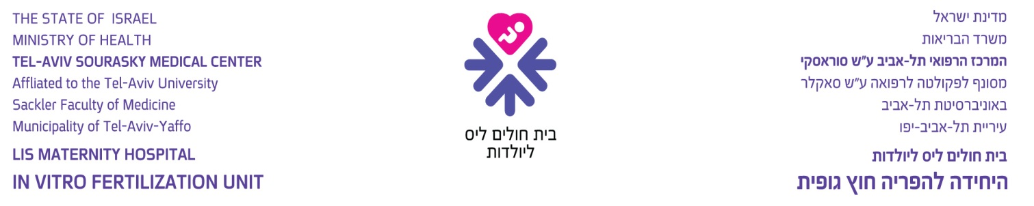

טופס הסכמה לטיפולי הפרייה חוץ גופית
Consent Form: In-Vitro Fertilization (IVF)

- General
In-vitro fertilization is performed in cases of impaired fertility, which may be caused by the following:
- Obstruction or functional damage of fallopian tubes.
- Ovulation disorders.
- Spermatic disorders.
- Immunological disorders.
- Unexplained infertility.
- Other.

The treatment is based on retrieving eggs from the woman’s ovaries and fertilizing them with her partner’s sperm. The fertilized eggs are incubated for 1 – 3 days and then transferred into the woman’s womb (uterus) or fallopian tube(s).

Chances of Success:
The chances of successful treatment vary and are influenced by the couple’s age, the condition of the ovaries, associated uterine, tubal, ovarian or pelvic pathologies, the quality of the sperm and additional factors. The exact probability of conception cannot be calculated for each case, but only a range of chances. There is no guarantee that the fertilization of the woman’s eggs will succeed and end in the birth of a child, nor can this probability be predetermined.

The chances of conceiving following one therapeutic course are 10% - 25%. The rate of live births per one therapeutic course are 8% - 18%, since approximately one fourth of all pregnancies end in miscarriage.

A child or children born of in-vitro fertilization may be physically, mentally or health-wise abnormal, including malformations or other defects, and genetic predispositions, or any other abnormality, just as in ordinary, natural fertilization.

- Hormone Therapy:
The chances of success are related to the number of embryos transferred into the uterus. Therefore, one of the goals of the treatment is to obtain a large number of eggs. In most natural cycles, only a single follicle matures. The use of medications enables recruitment of a large number of follicles and enhances the chances of removing more eggs. Thus the chances of achieving more embryos to transfer into the uterus are higher. Some of the medications administered to stimulate the ovary are used to control certain hormones and other are used to suppress the pituitary – ovarian axis and thus enhance the effectiveness of the treatment.
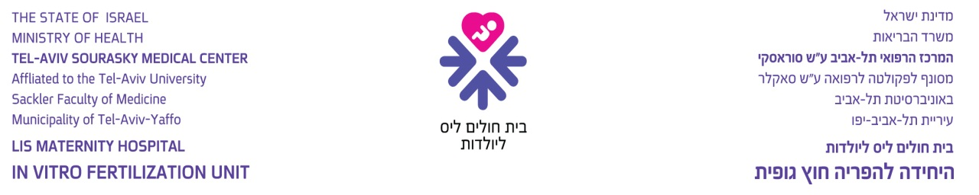

- The Risks of Hormone Therapy:
Hormone therapy often leads to hyperstimulation of the ovaries. Such hyperstimulation is usually mild and manifests in swelling of the abdomen, abdominal pain, enlargement of the ovaries and even slight

accumulation of fluid in the abdomen. These symptoms and signs subside approximately 3 – 4 weeks after
the eggs are removed, but if conception is achieved they may last longer. Rest and increased intake of fluids usually suffice as treatment, and hospitalization is usually not required.

Moderate or severe hyperstimulation are very rare. Moderate hyperstimulation includes, in addition to the aforementioned, nausea, diarrhea and over-concentration of the blood. Severe hyperstimulation (0.5% - 5%) also involves the risk of pulmonary infiltrations and emboli. Additional rare complications include heart and/or kidney failure. Isolated cases of limb amputations and even death have been reported.

It is important to note additional rare complications, such as ovarian torsion, rupture or hemorrhage. These complications necessitate surgical intervention (open or laparoscopic) to release the torsion. In rare cases, the need to resect the ovaries has been reported.

Solitary reports have recently appeared in the medical literature, examining the possibility of an increase in the incidence of ovarian cancer following treatment with ovulation stimulating agents. These reports have not been confirmed by additional studies and are mentioned here for caution only, since information is still accumulating and the conclusions will only be available in several years.

When treatment includes premature suppression of the ovaries, side effects similar to those of menopause may occur. In addition, ovarian cysts may develop, requiring their removal and/or discontinuation of treatment. Allergic reactions to the hormone medications are rare.

Reporting any unusual occurrences to the attending physician at an early stage will facilitate diagnosis and early treatment.

- Laboratory and Ultrasound Tests
Before beginning treatment, in addition to the standard tests, the couple will be required to perform blood tests for HIV and hepatitis B and C antibodies.

The development of the follicles (and eggs) in the ovaries is monitored and followed by hormonal blood test and/or vaginal ultrasounds.

- Retrieval and Fertilization of Eggs
The retrieval is usually conducted under local or general anesthesia. The procedure is usually performed by vaginal approach, under ultrasonographic guidance, and in rare cases by abdominal approach. In rare cases, the procedure is performed laparoscopically.

The fertilization occurs following incubation of the eggs with the sperm under special laboratory conditions.

The Risks of Egg Retrieval:
The egg retrieval procedure entails discomfort and even pain, and following the procedure a few hours of rest are required. The main risks associated with the insertion of a needle into the ovary are infection and hemorrhage. Pelvic infection is rare and usually resolves with antibiotic treatment.

At times, surgery is required to drain an abscess or resect damaged fallopian tubes or ovaries. Infections reduce the chances of conceiving. In rare cases, complications of the infection may necessitate resection of the uterus. Mild hemorrhage occurs during most manipulations of the ovary. Infrequently, the hemorrhage is more extensive and requires blood transfusions, procedures to stop bleeding, and resection of the ovaries and uterus. Damage to the intestine is rare but possible.

- Micromanipulation

Micromanipulation is a laboratory procedure performed to achieve the following goals:
Fertilization
The procedure is performed in cases of low-quality sperm that does not enable regular fertilization, and in cases where there were no fertilizations or a low percentage of fertilizations in the past, or when the fertilization was defective.
The technique is termed ICSI (Intra Cytoplasmic Sperm Injection), and it involves injection of a solitary sperm into the egg using microscopic needles.
Assisted Hatching
This technique is called AZH (Assisted Zona Hatching) meaning that the embryonic envelope is treated to enhance implantation. This method is used to open a “window” or make the embryonic envelope thinner using mechanical or chemical means, or a laser beam.

The Risks of the Micromanipulation Technique:
These techniques are still defined as experimental. Follow-up thus far has not indicated a significant increase in the risk for newborns. Any risks that may exist will only become apparent in the future.

The ICSI technique may increase the probability of genetic disorders, though only slightly. Men with extreme sparsity of sperm may transfer this trait to their sons.
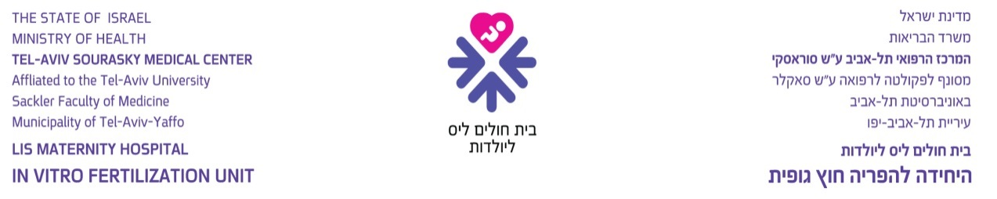

- Incubation
The eggs, and later the embryos, are incubated in the laboratory for 1 – 3 days in order to maintain optimal conditions for the embryos’ development.

- Transfer of Fertilized Eggs (Embryos):
This procedure can be conducted in one of the following ways:
Embryo Transfer (E.T.)
The embryos are loaded on to a plastic tubule and placed in the uterine cavity via the uterine cervix, 2 – 3 days after fertilization. This procedure is usually performed without anesthesia.
Tubal Transfer
A prerequisite for tubal transfer is proper condition of the fallopian tubes, and therefore, this technique
is enabled only when there is no mechanical tubal infertility. The natural fertilization and embryo development occurs in the fallopian tube during the first 3 – 4 days. It is assumed that if the eggs and sperm, or the fertilized eggs, are placed in the fallopian tube, the natural surroundings will enhance the chances of success. This procedure is at times performed under anesthesia.

Tubal Transfer can be performed for:
7.2.1 Eggs and sperm on the retrieval day. This procedure is termed GIFT (Gamet Intrafallopian Transfer).
7.2.2. Fertilized eggs on the day following retrieval. The fertilized egg at this stage is termed zygote and therefore, the technique is named ZIFT (Zygote Intra Fallopian Transfer).
7.2.3. Fertilized eggs at a later stage of embryonic development. This technique is termed T.E.T. (Tubal Embryo Transfer). The embryo can be transferred into the abdominal opening of the fallopian tube by laparoscopy or into the uterine opening of the tube through the uterine cervix – T.C.T.E.T. (Trans Cervical Tubal Embryo Transfer).

The Risks of Transferring Fertilized Eggs (Embryos):
The transfer of embryos into the uterus is a relatively simple procedure, usually conducted without the use of any anesthesia. In some cases the uterine cervix is too narrow to allow transfer and its dilation may cause mild pain.

The transfer of embryos into the uterine cavity involves the risk of pelvic infection, which is associated with the risks detailed in section 5 above. When the fertilized eggs are transferred laparoscopically into the fallopian tube (using procedures such as GIFT or ZIFT), several instruments are introduced through the abdominal wall to enable visualization of the pelvic organs and surgical procedures, including the transfer of the embryos. Laparoscopies are usually performed under general anesthesia. Since CO2 gas is injected into the abdominal
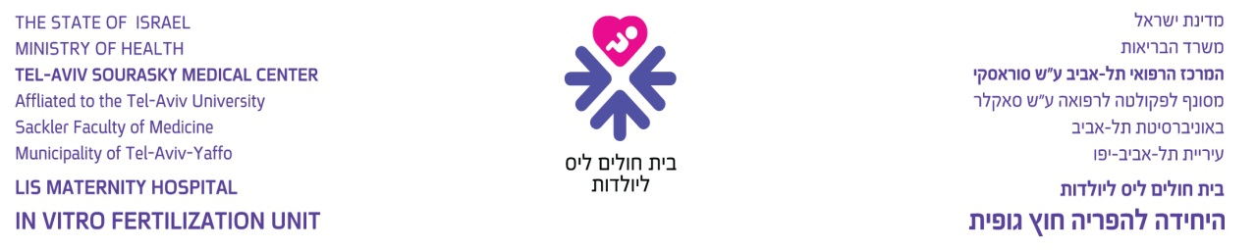

cavity during the laparoscopic procedure, shoulder and abdominal pain are expected immediately after the procedure and for several hours following it. The possible risk involved in laparoscopies, aside from the risks associated with anesthesia (see section 9 below), is damage to the internal abdominal organs, such as: the intestine, the urinary bladder and blood vessels, which will at times require opening the abdomen for surgical repair. Rare cases of death have been reported in association with laparoscopies.

- The Risks of Pregnancy and Multifetal Gestation
The rate of multifetal gestations following fertility treatments is especially high (up to 30%). In cases of mutlifetal gestations, it is customary to offer selective reduction. The possible risks involved in this procedure are: immediate or delayed miscarriage, pelvic infection with all its associated risks (see section 5 above), and premature delivery.

Multifetal gestations entail complications such as premature or late miscarriage, premature rupture of membranes requiring termination of pregnancy, and delivery of premature babies. The risks of prematurity include, among others, motor impairments, brain and neural damage and prolonged hospitalization. Multifetal gestations carry a high rate of caesarean section deliveries. In addition, it should be noted that fertility treatments involve an increased risk of ectopic pregnancies (1% - 5%), necessitating surgical

intervention and at times resection of the fallopian tube to protect the woman from physical harm or life threatening situations.

- The Risks of Anesthesia:
Anesthesia is a relatively safe procedure, but it does involve certain risks.
The risks of local anesthesia are various degrees of allergic reactions to the anesthetic drugs. The risks of epidural anesthesia are allergic reactions and damage to the nerves of the lower body. The risks of general anesthesia include damage to the teeth and/or vocal cords due to the introduction of a tube into the windpipe, various degrees of allergic reactions to the anesthetic drugs and in very rare cases, death. Therefore, it is essential to report any known sensitivity to medications in advance. With general anesthesia there is also a risk of aspirating gastric content. Fasting for 6 hours at least reduces the risk of aspiration.

- Cryopreservation:
This procedure is performed when there are high-quality embryos in addition to those transferred back to the woman. The frozen embryos will be used as agreed: for additional treatments, if such are conducted, or for surrogacy, or when the embryos need to be preserved so that they may be transferred at a later date due to the woman’s condition at the time. A computerized freezer is used for cryopreservation. The frozen embryos are stored at a temperature of -196ºC, in test tubes or tubules.

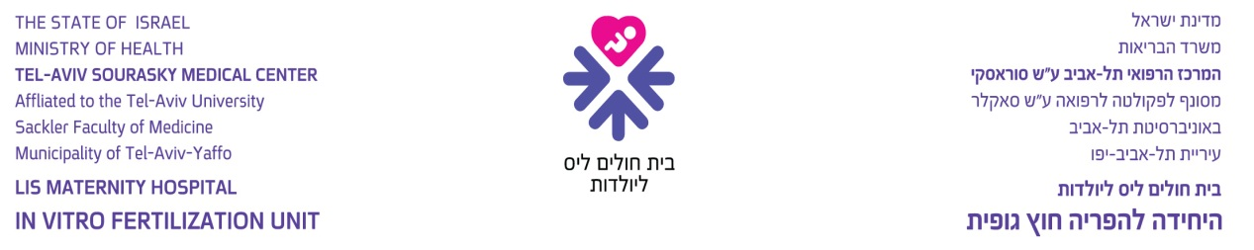

According to the directives of the Ministry of Health, embryos can be preserved for five years. After five years, the couple must instruct the hospital if they wish to continue preservation for an additional five years. Preservation will be continued only after receiving a written request to prolong the cryopreservation, signed by the woman from whom the eggs were taken and her husband, and authorized by signature of the physician in charge.

Risks and Complications of Cryopreservation:
Cryopreservation succeeds in approximately 75% of the cases, and the thawing process succeeds in approximately 50% of the cases. The rate of pregnancies from frozen embryos is low (8% - 16%). The long term risks of delivering frozen embryos are not known. Ten years of experience so far have not indicated any increased risk.

- Technical Failure:
In vitro fertilization involves a series of surgical procedures, laboratory work and delicate technical activities, requiring the activation of mechanical and electronic equipment. The success f the procedure depends on the proper functioning of an entire system. At times, though not often, fertilization may fail

on a technical level. Technical failure may occur in up to 1% of cases, in the retrieval of the eggs, their fertilization, the transfer of the embryos, the freezing of the embryos, their preservation or thawing.

I/We, the undersigned: ______________ ______________ (henceforth: “the woman”)
Name of Woman ID No.
______________ ______________ (henceforth: “the husband”)
Name of Husband ID No.

Hereby declare and confirm that I/we have been given a detailed oral explanation by:
Dr. ______________ ______________
Last Name First Name
regarding the in-vitro fertilization treatment procedures (henceforth: “the treatment”).

I/we have thoroughly read the consent, including the detailed information concerning the various stages, the side effects and the possible risks involved in the treatment. In addition, I/we have been given detailed explanations from the attending physician concerning details that were not clear to me/us and detailed answers to all my/our questions, and I/we agree to the performance of all the surgical and laboratory procedures required in order to increase the changes of success at each of the treatment stages. I/we hereby declare that I/we have been given an explanation and understand that there are potential risks at each stage and I/we am/are willing to take those risks upon myself/ourselves.

I/we hereby freely give my/our full consent to the in-vitro fertilization staff at __________________________________________
(Name of Institute)

to the doctors, nurses, laboratory personnel and the staff at the in-vitro fertilization program, to perform all the treatment procedures detailed above, at their discretion, in keeping with the hospital’s procedures and directives and standard degree of responsibility and in accordance with the law, and that the person in charge of the fertilization will be _____________________________ (complete for private patients).
Name of Physician

I/we have been given an explanation and understand that my/our medical insurance may not cover the entire cost of the treatments I/we will require, and that in such a case I/we will have to pay the necessary expenses myself/ourselves.

I/we am/are aware that I/we have the right to withdraw from the treatment program at any time, but such a decision will be my/our own full responsibility.

Signatures: _____________________________ _____________________________
The Woman The Husband
Date: ______________________

I hereby confirm that I have given the woman and her husband a detailed oral explanation of all the above-mentioned facts and considerations as required and that they have signed the consent form in my presence after I was convinced that they fully understood my explanations.

____________________________________________ ______________________
Name and Signature of Physician License No.

